**Political Juggernauts: A Quantitative Analysis of Candidates in the 2019 Lok Sabha Elections**

**1.Introduction** :

***The Lok Sabha is composed of representatives of people chosen by direct election on the basis of Universal Adult Suffrage. The Constitution of India allows for a maximum of 550 members in the House, with 530 members representing the States and 20 representing the Union Territories. The 17th Lok Sabha was formed by the members elected in the 2019 Indian general election. Elections, all across India, were conducted in seven phases from 11 April 2019 to 19 May 2019 by the Election Commission of India.***

***The Bharatiya Janata Party received 37.36% of the vote, the highest vote share by a political party since the 1989 general election, and won 303 seats, further increasing its substantial majority. In addition, the BJP-led National Democratic Alliance (NDA) won 353 seats.***

**2. PROBLEM DEFINITION AND DESIGN THINKING : 2.1 empathy map :** 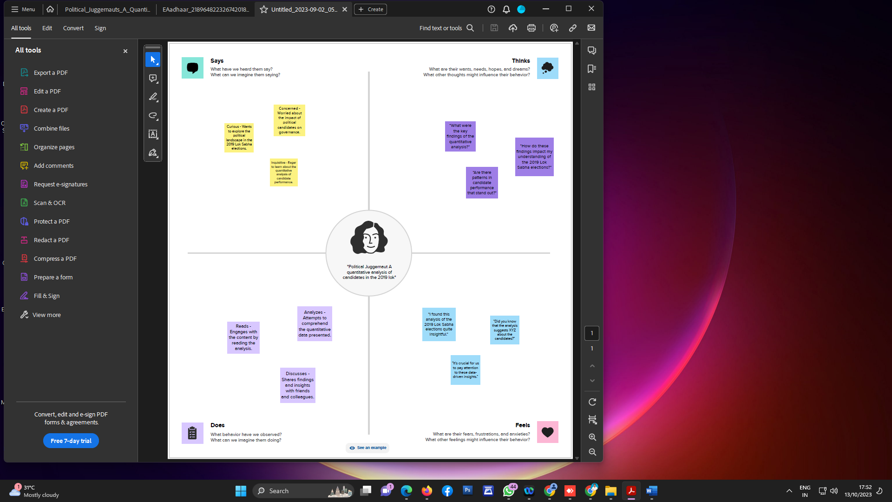

**2.2 brainstorming map:**

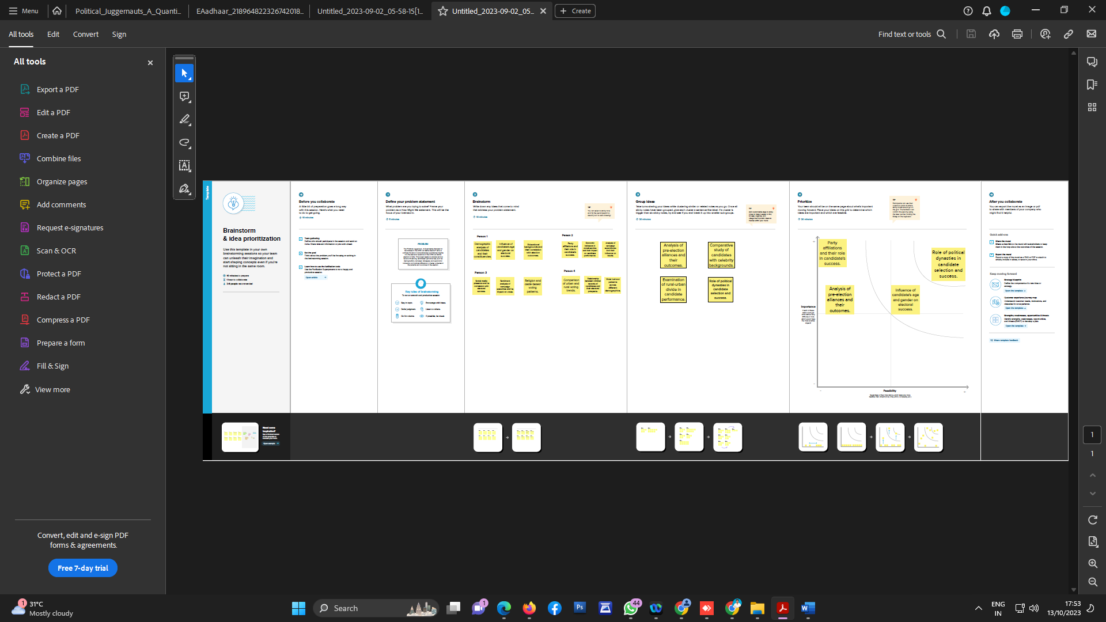

3.RESULT :

